***Karan Kumar-Batch7-Assigment***

***Karan Kumar-(CEQ-539)***

AWS TRANSIT GATEWAY:

AWS Transit Gateway is a network transit hub that allows you to connect multiple Amazon Virtual Private Clouds (VPCs) and on-premises networks together in a centralized and scalable way, simplifying network management and reducing operational costs.

1. A Transit gateway is a network Transit hub.
2. Transit gateway connect vpc and on-premise networks to a central hub.
3. It simplifies the network and puts and end to the complex peering. It acts a cloud router.
4. Each connection is just made once.
5. A tag scales elastically and the traffic management is very easy.
6. Our data is automatically encrypted and can never travel overs public internet.
7. Inter region peering connects aws TG together using aws global network.
8. Routing through the TG operates at layer 3 I.E ossi model.

Create Transit Gateway:

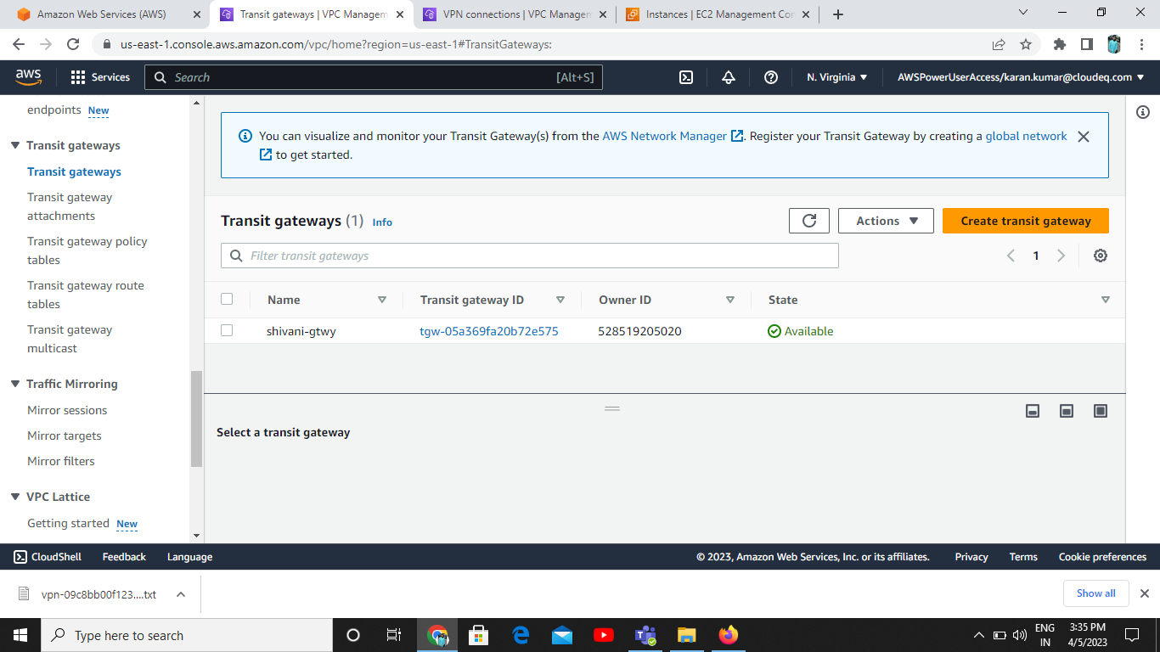

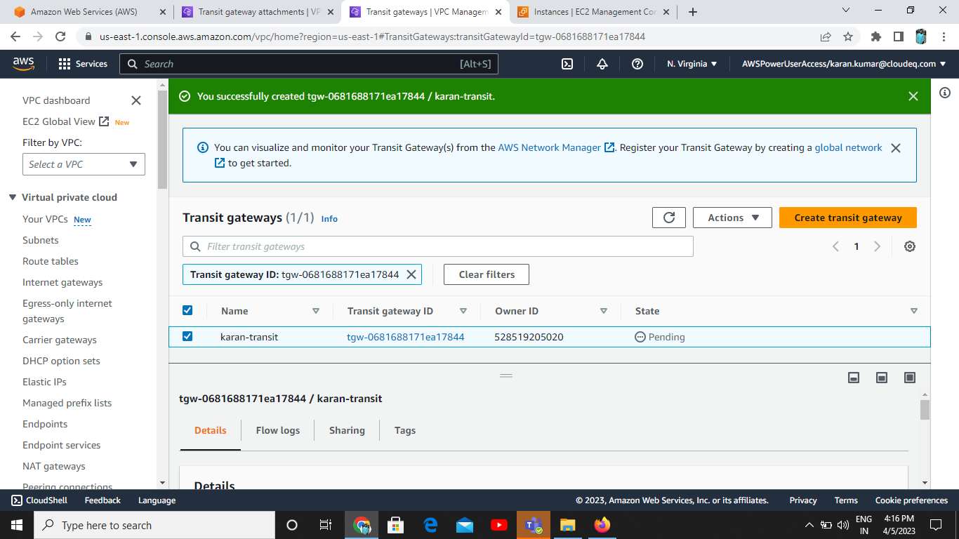

Create Transit Gateway Attachment:

First VPC Attachment:

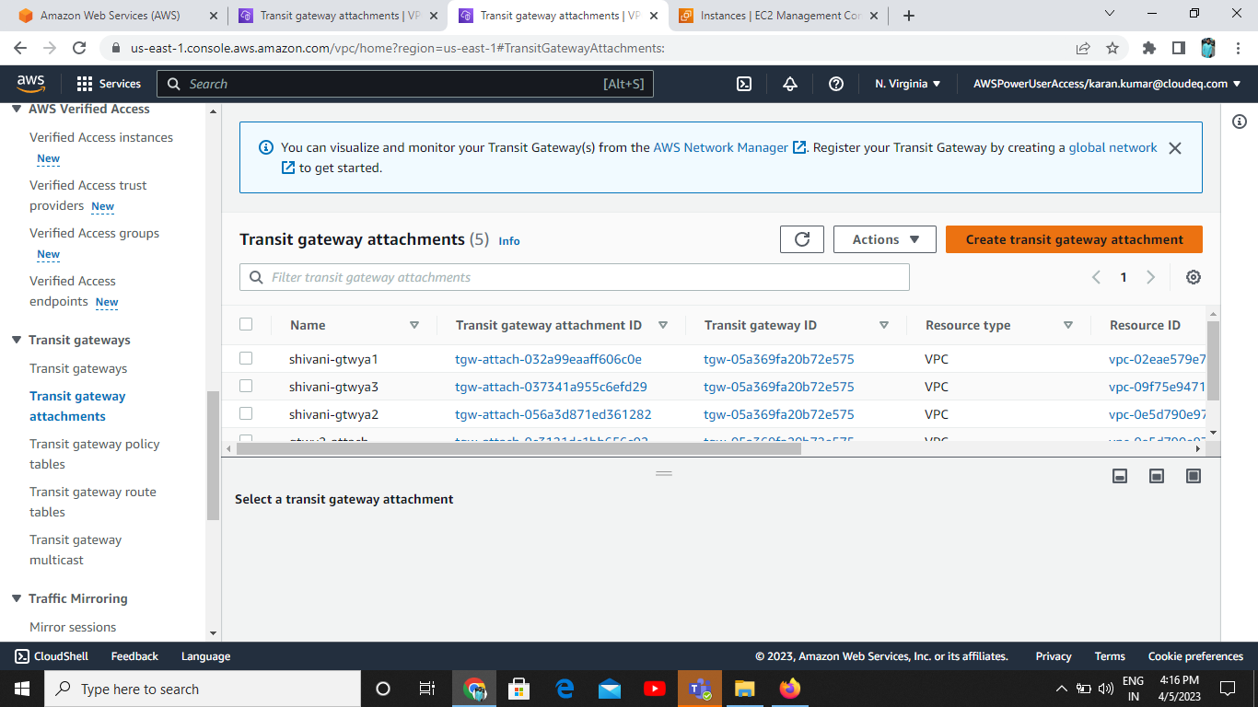

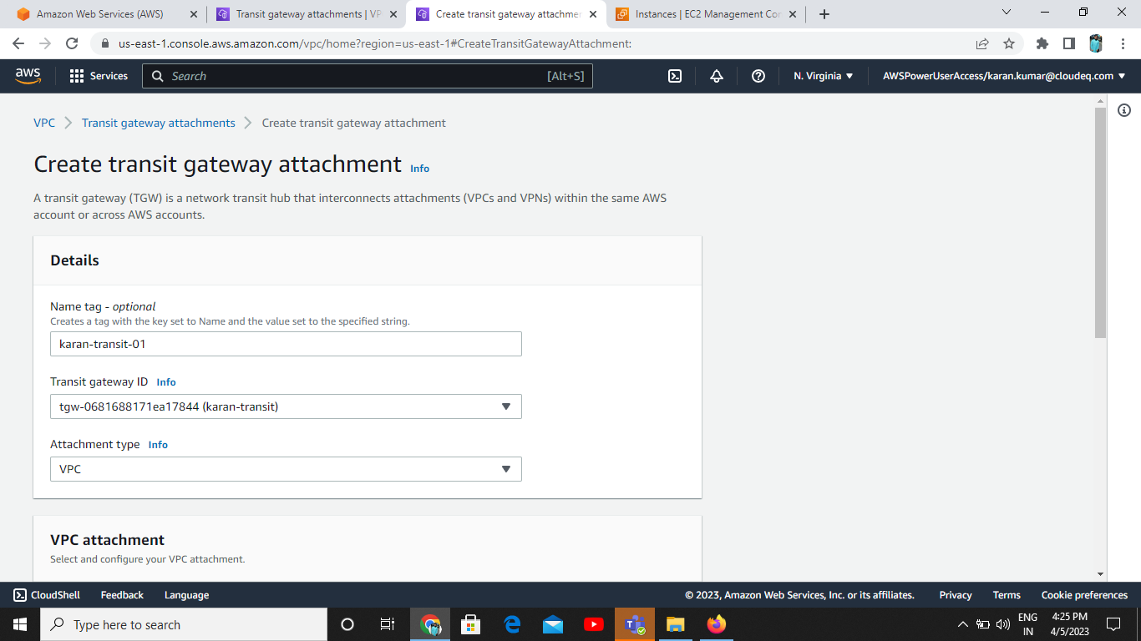

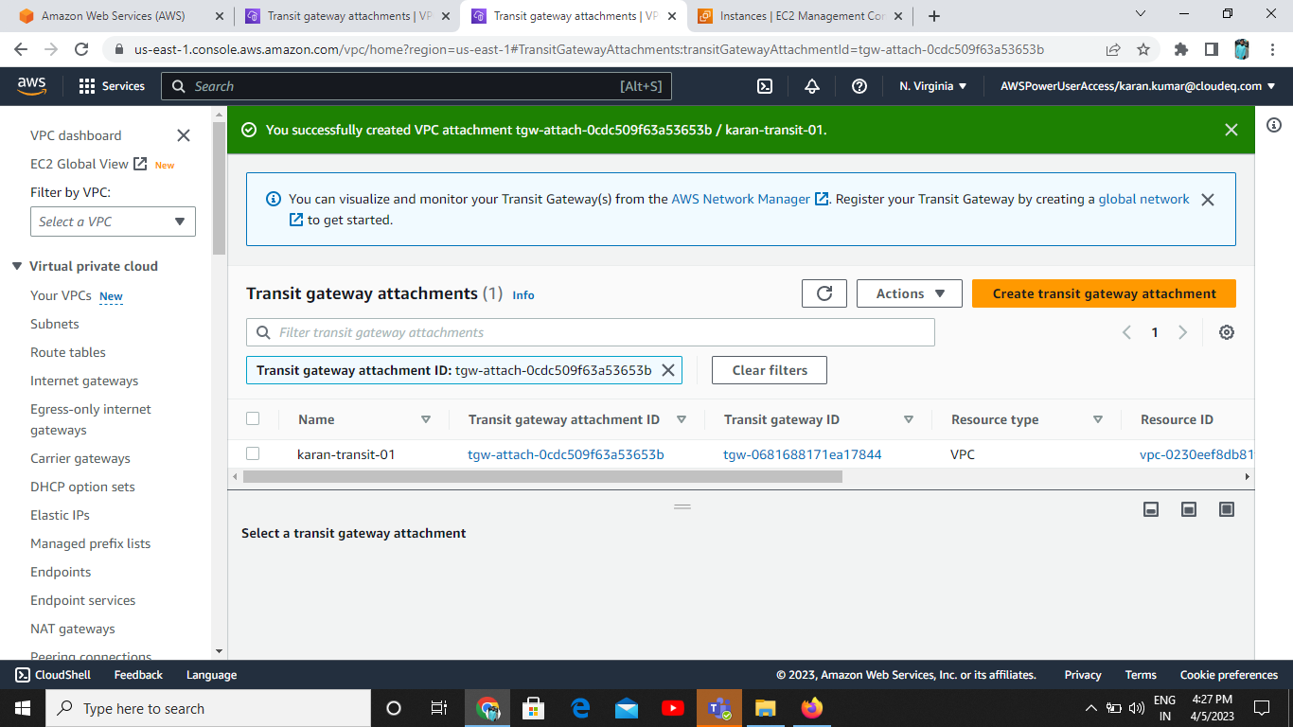

Second VPC Attachment:

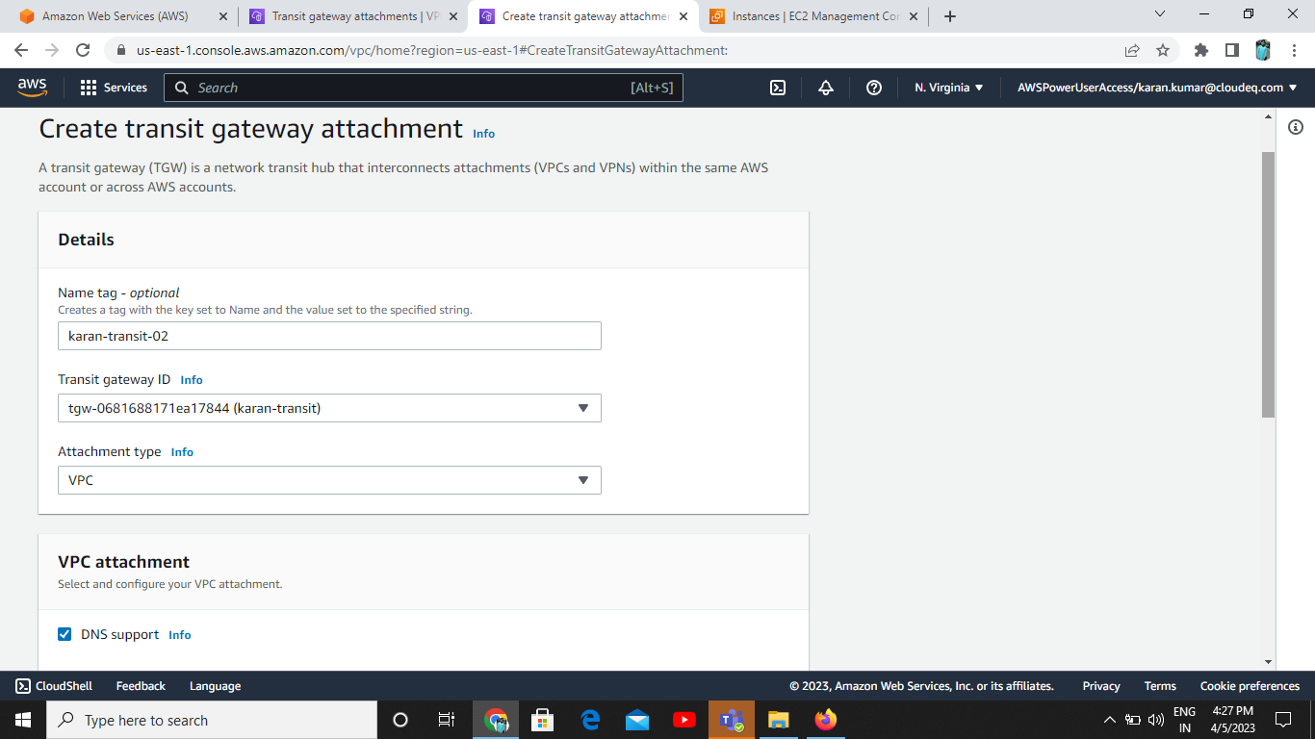

Result of Attachment:

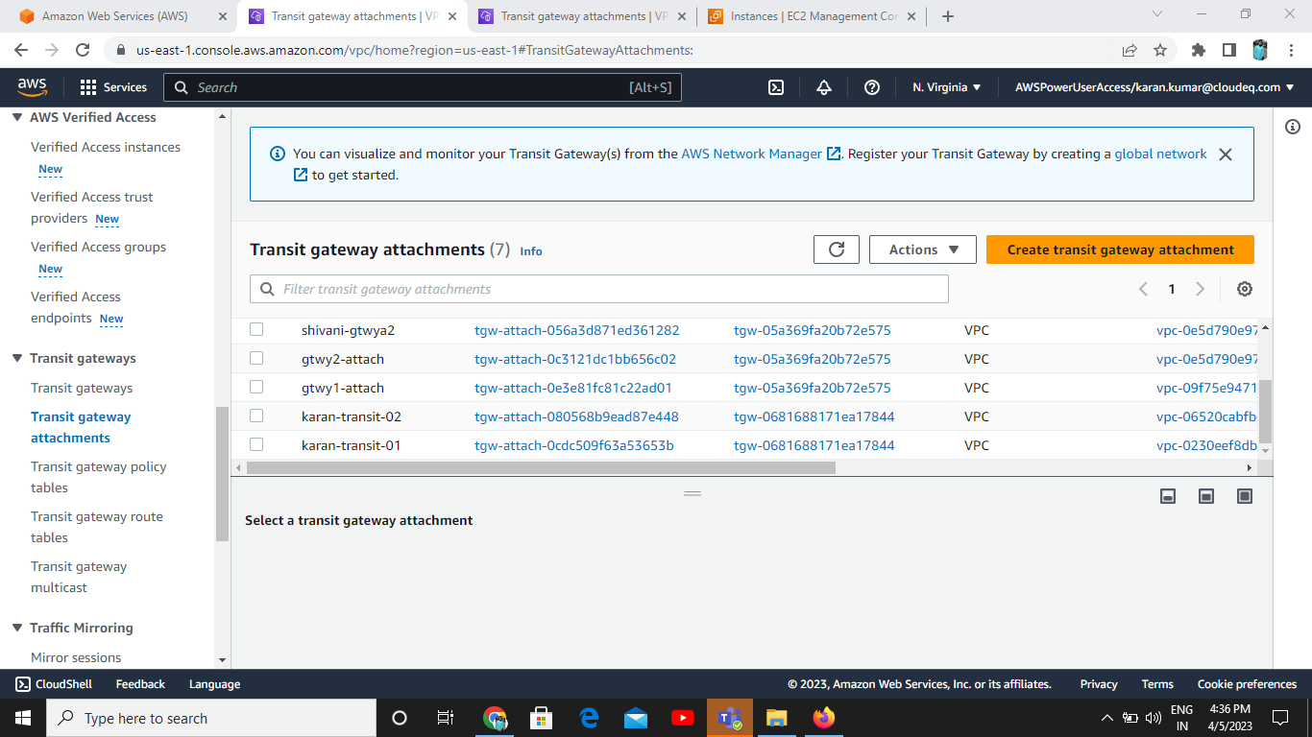

Create transit gateway policy table:

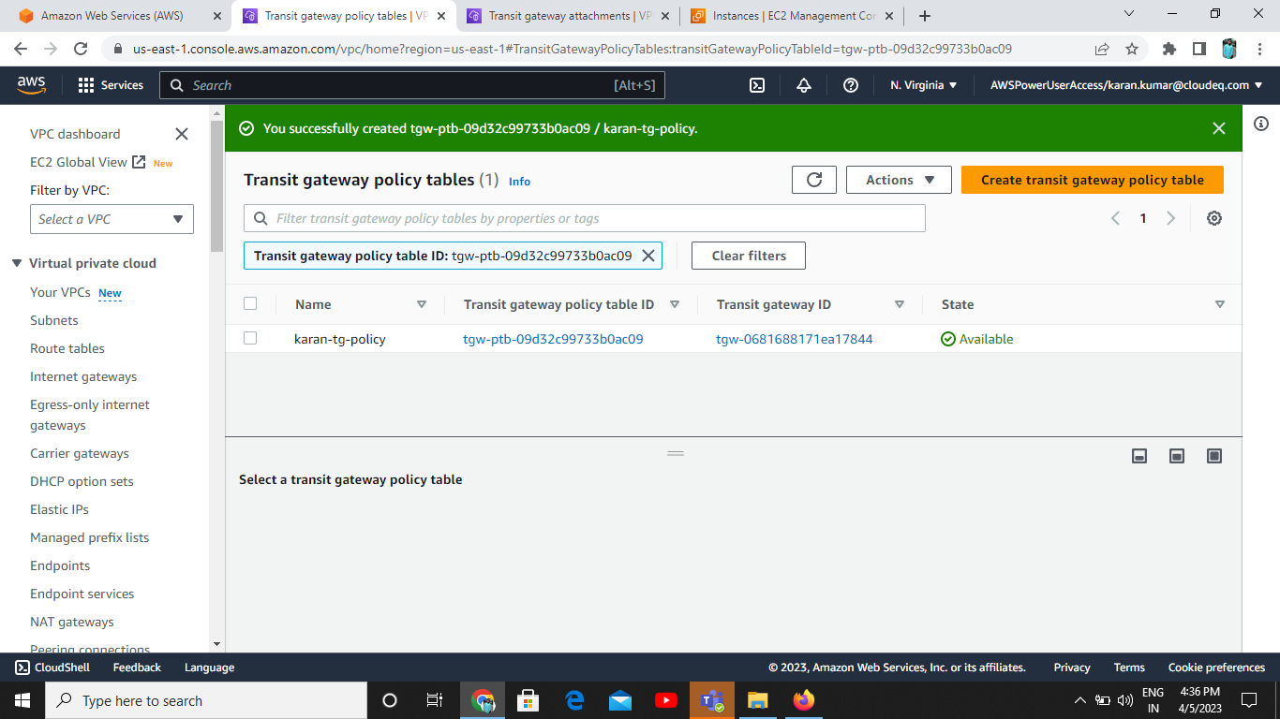

Create Transit gateway route table:

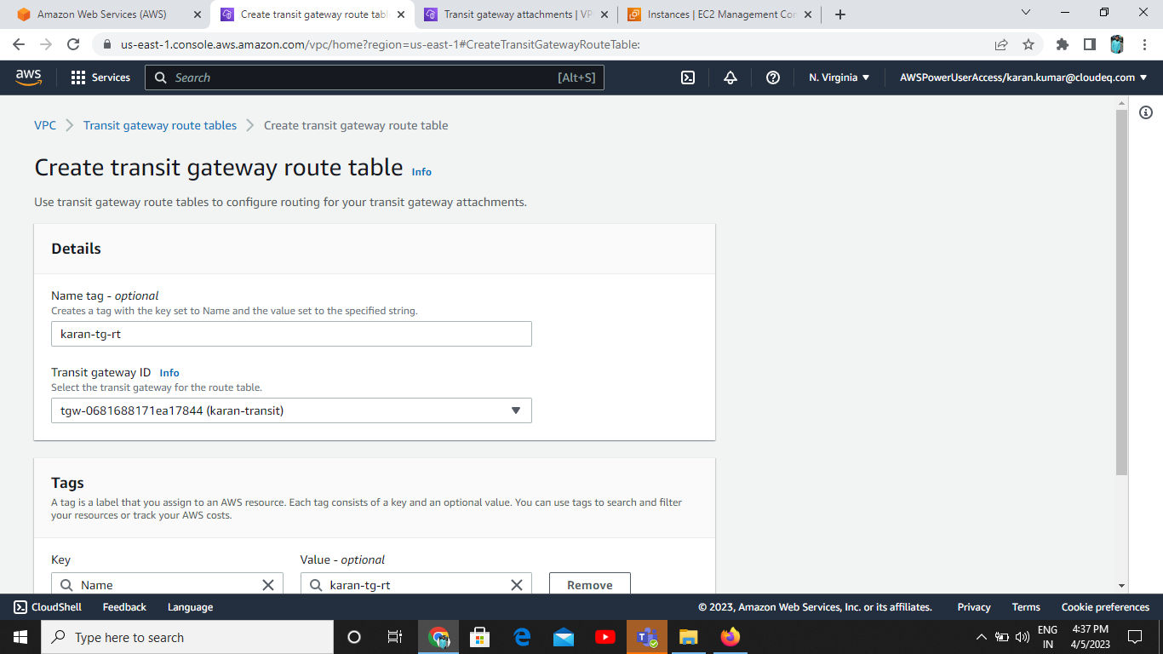

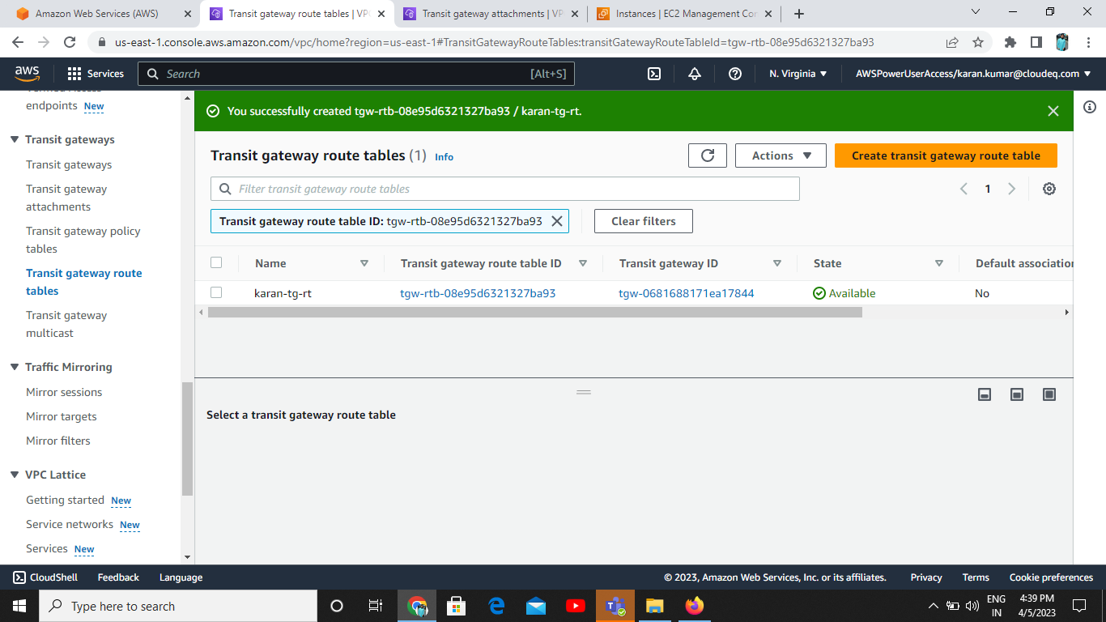

_____________________Thank You______________________